westsussex.gov.uk

Drama Workshop for 4-8 year olds 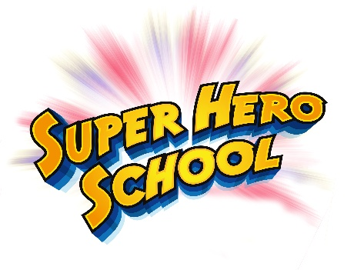


Chichester Library
Wednesday 12 August
10.00–10.30am or 10.45–11.15am

Fly to Superhero School for an action-packed mission to save the world.

Your child will discover their own special powers and you’ll see their confidence zoom at this one-off fun session.

Booking essential – please speak with staff to reserve a place

Parents and carers must remain with their child during this activity

